



**Success of the New Pruno Day**

**\*** **Full capacity to enjoy a unique wine tourism experience at the first Ribera del Duero Golden Mile festival**

**Ribera del Duero, June 2024 (Valladolid). The new format presented on this Pruno Day met the expectations of this event, now in its seventh edition. Wine and music lovers lived last Saturday 22nd at Finca Villacreces a unique day where wine and nature joined culture in one of the most magical days in the Milla de Oro of la Ribera.**

The new format presented at this year’s Pruno Day met the expectations of this event, which celebrated its seventh edition. Last Saturday 22nd, wine and music lovers lived a unique day in Finca Villacreces, where wine and nature joined culture in one of the most magic days in Milla de Oro of la Ribera.

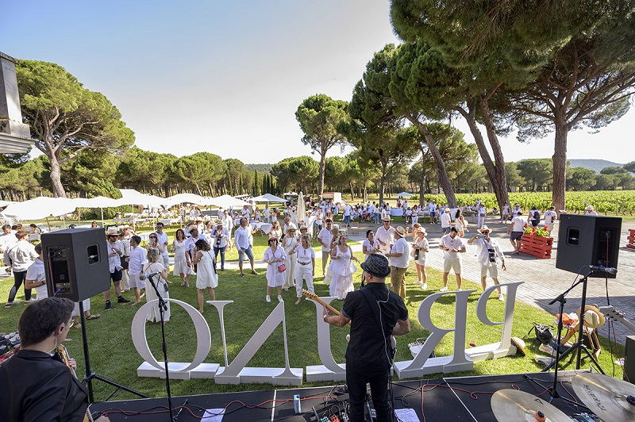Finca Villacreces celebrated last Saturday 22nd the seventh edition of its Pruno Day, in which half a thousand people were able to enjoy a new format in which the musical program raised high the experience of this event on the banks of Duero. In addition to the activities that give Pruno Day its own identity and help visitors to fully immerse themselves in the wine culture, the bet on music rounded off an exclusive experience.

It was the band from Valladolid, Agusta Sonora, one of the great promises of national indie, who inaugurated the musical program with a large waste of energy in a clean and measured lived performance.

For his part, Luis Brea gave a concert with songs from his latest album and reviewed his already extensive curriculum in which he mixed different styles such as folk, bossa nova, new wave and indie, which helped him to connect with a crowd that knows him really well.

The icing on the cake was provided by the singer from Madrid Depedro who, in the middle of the presentation of his new album, made a stop at Finca Villacreces to perform an acoustic set at the height of very few, in which was no shortage of what are already anthems of a generation, thanks to its mestizaje and sensibility.

All these songs were joined by the wines produced by the winery Finca Villacreces, and whose protagonist is the Pruno wine, that gives its name to this day. Attendees were also able to enjoy the activities organized by the winery: wine casino, a ride on the Pruno Express train, guided tour of the winery and the ‘anticata’, all surrounded by a bicentennial pine forest with a the back drop of the of ecologic vineyards of Finca Villacreces.

***Informative note:***

*Finca Villacreces has been hidden, for centuries, in a unique natural environment, between its vineyards, the Duero and a forest of centenary pines. All of this interweaving of nature and vineyards has placed Finca Villacreces among the 10 most visited wineries in the Ribera del Duero. There, it produces the wines Pruno (best wine in the world quality/price in 2012 and 2015) Finca Villacreces, Specimen and Nebro. Pruno Day has been awarded in IWC awards, Verema awards and Rutas del Vino awards, among others.*

**For more information:**

Finca Villacreces- Iván Pérez – [iperez@artevino.es](mailto:iperez@artevino.es) - 616 510 586

10vcomunicación – Victoria Díez - [victoria@10vcomunicacion.es](mailto:victoria@10vcomunicacion.es) - 629 682 802